Docker Version (preparations)

Hello-world, Docker (exercise 1, step 1)

Docker images (exercise 1, step 2)

Docker Containers (exercise 1, step 3)

Command 1 (exercise 2)

Command 2 (exercise 2)

Command 3 (exercise 2)

Command 4 (exercise 2)

Command 5 (exercise 2)

Command 6 (exercise 2)

Command 7 (exercise 2)

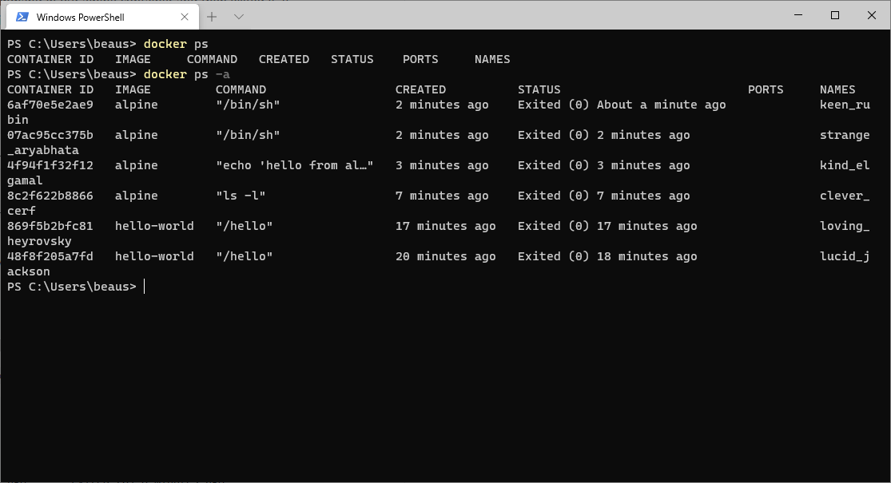

Command 1 (exercise 3)

Command 2 (exercise 3)

Command 3 (exercise 3)

Command 4 (exercise 3)

Command 5 (exercise 3)

Docker static website (exercise 3)

Docker build (exercise 3)

Docker run (exercise 3)

Docker running my app (exercise 3)

